Exercise 2

Please visit the Dockerhub site and search for the repository **awssameerzulfi/mybeginnersoldsite**

Go through this repository and find out tags section and the pull command etc.,

Our goal is to run the below site and you should get the output like this

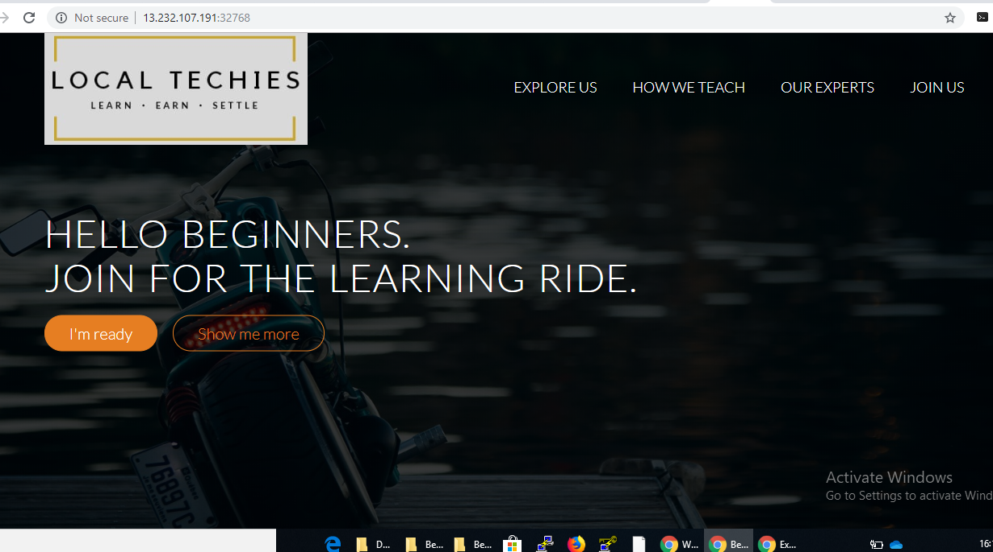

1. I want you to run the container directly with some host port # ( remember container port default is 80) and it should be always running.
2. After this try to access the site using the public ip with the host port. If you get the above page, Go and Have a Beer. ☺

Let’s try something else. This time run the container but don’t specify exclusively the HOSTPORT#

Rather just add “-P” then the container will start running.

After that type this command “docker port <containername>” which will give you the port details.

Now try to access the publicip:hostport#

You should get the same site.

Now stop the Container and try whether you are able to access.

Restart the container and see whether it works or not.